Assignment – File System

)Make a directory structure like this in your home directory

Ans: mkdir -p demo_dir/{inside_demo,also_inside_demo/{abc,abc_123}}

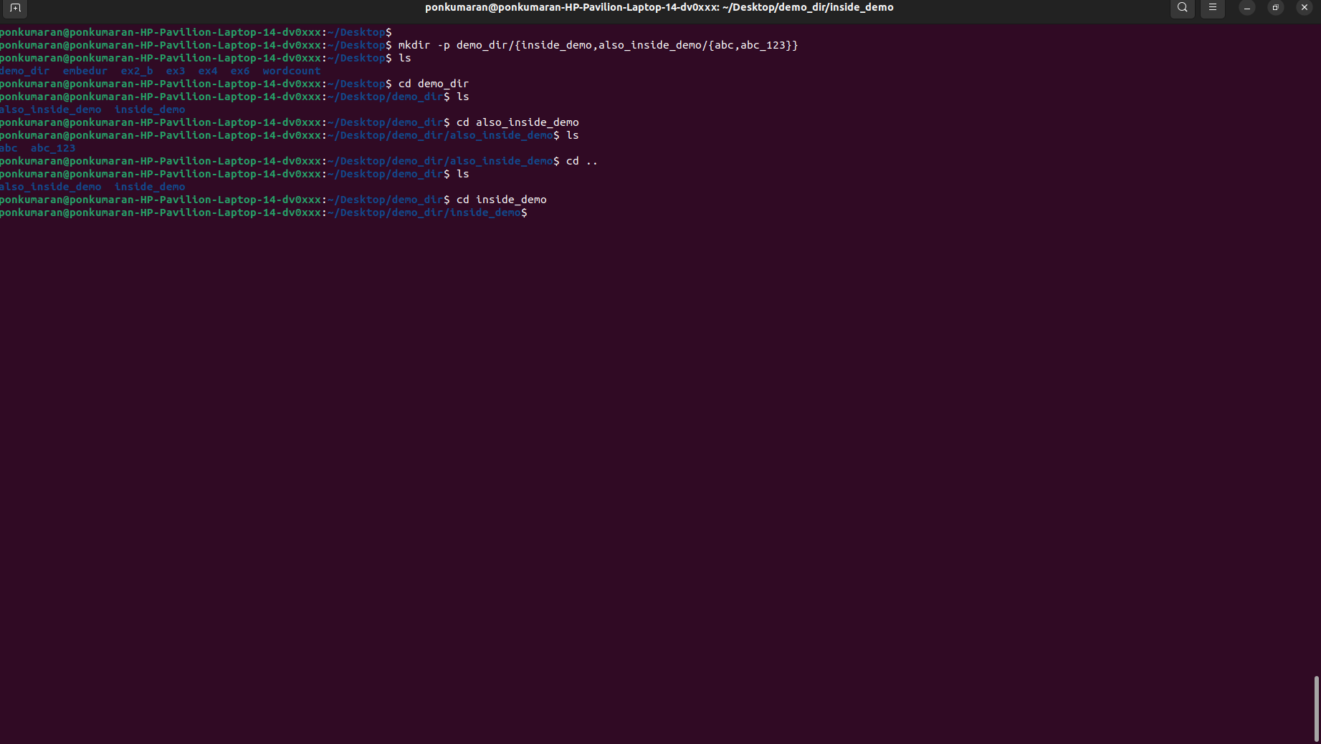

2) Remove the also_inside_demo directory

Ans: rm -r also_inside_demo

